RPL Continued
KPIs in Transport and Logistics
Many people get confused about KPIs or Key Performance Indicators in Logistics and Supply Chain operations. Which ones to use? How many to use?
Sadly, it’s not such an easy question to answer. Of course, your supply chain and logistics KPIs need to be SMART—Specific, Measurable, Achievable, Relevant, and Time-phased—but this may too rudimentary a set of rules to ensure KPIs are useful. I will suggest some rather more comprehensive guidelines, but for now, aside from applying the SMART acronym, my basic take on KPIs is this…
1) Don’t have too many! I’ve seen KPI “packs” the size of phone books, and even KPI sets circulated as a monthly magazine… that no one reads. Remember what the K stands for!
2) make sure they “tie” in with your goals and objectives. Do they directly support those objectives?
Therefore, the figure below shows some of the KPIS to use in the Transport & Logistics industry in Australia:

A example of a KPI Dashboard with Inventory
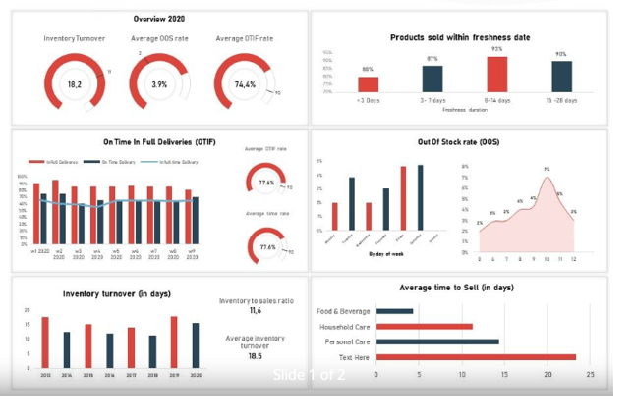

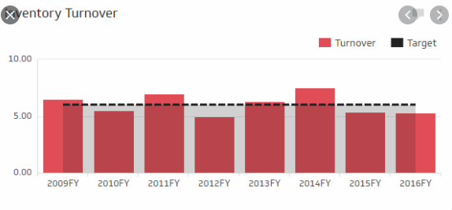
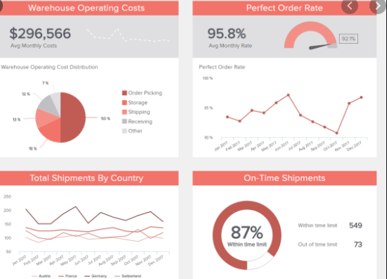

Transport and Logistics Rosters
A roster is a timetable that shows the days and times employees are required to work.
When an employer wants to change an employee’s regular roster or ordinary hours of work, they have to discuss it with the employees first. They have to:
Provide information about the change (eg. what the change will be and when)
Invite employees to give their views about the impact of the change
Consider these views about the impact of the change.

Maximum number hours
The maximum number of ordinary hours employees can work is:
- 8 hours per day
- an average of 35 hours per week for oil distribution workers
- an average of 38 hours per week for all other workers.
Check clause 22 of the Road Transport Award for information on how to change ordinary hours.

Averaging weekly hours
An employer and their employee can average the employee's hours over more than a week.
This means the employee may work more than hours one week, but less in another.

Options for averaging weekly hours
Oil distribution workers can average their 35 hours per week by working 70 hours over a 2 week period.
The table below shows the options for averaging 38 hours per week for all workers other than oil distribution workers.
Hours worked | Averaged over…
76 hours | 2 weeks in a row
114 hours | 3 weeks in a row
152 hours | 4 weeks in a row

Transport and Logistics Target chart
Australia’s Third-Party Logistics market size, by service, 2016-2927 (USD Billion)
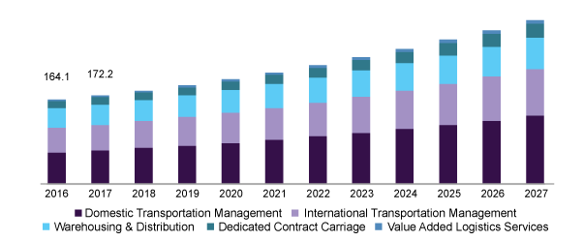
Transport and Logistics Sales chart
